6:45 Greeter:
6:50 Quiet Settling with Soft Music
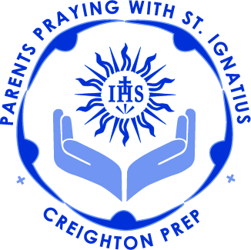
7:00 Call to Prayer (Mark Link, SJ): Volunteers
7:03 Review of Examen and Colloquy.
7:15 Teaching: Fr. Schneider, SJ
Paschal Mystery
Holy Week & Easter
The transition from Phase 3 into Phase 4 of the Spiritual Exercises Retreat.
Meditation for Holy Week

7:50 Mr. Sterling Brown: Dean of Students
8:10 Week/Phase 3 Scriptural Readings
8:15 Intentions:
8:25 Announcements:
Interest in Leadership roles
BASH fast approaching-if you attend please check out the PPWI baskets.
April 12th 3:00pm on Memorial Plaza, west side of Prep: End of Year Rosary for Prep Community especially graduating seniors

May 13, 2017: Last PPWI gathering of this year, Celebrating 12 years:
Mass with Fr. Kevin in Prep Chapel
followed by end-of-year celebration in the Creighton Room

8:28 Call to Mission (Mark Link, SJ): Volunteers

