7:00 Call to Prayer:
7:13 Teaching for Phase 4 of retreat:
7:20 Contemplation
Painting:
http://www.ignatianspirituality.com/20988/arts-faith-easter-imaginative-prayer-exercise-2
The Resurrection:
http://www.ignatianspirituality.com/21162/contemplating-the-resurrection
7:55 Faculty Guest: Fr. Schneider
8:15 Intentions:
8:23 Announcements :
Faculty / Staff Prayer Reminder
BASH basket: Present … Sell!!!
Leaders for Next Year… Interested?…
This Semester dates: Meeting is 5/18 (Mass & Social)
The Rosary is
- April 29 (Wed) @ 3pm @ Prep, West Commons Entrance
8:27 Review:
8:29 Call to mission & Prayer for Generosity:
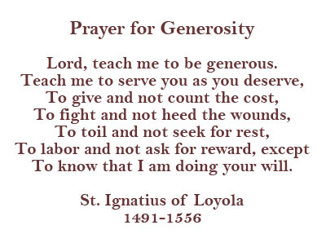
Our Website is:
http://prepase.weebly.com/april2.html

