7:00 Call to Prayer
7:03 Meditation on 2 Standards
7:20 Transition from Phase 2 – Phase 3 of retreat
7:35 Video and Sharing: Eucharist
(http://bustedhalo.com/video/sacraments-201-eucharist-what-we-believe)
7:55 Guest Speaker : Mrs. Linda Pfenning
8:15 Petitions
8:23 Announcements
Faculty / Staff Prayer
BASH basket: Need Now
Leaders for Next Year… start thinking…
This Semester dates: Meetings are 3/16, 4/13, 5/18
The Rosary is
- April 29 (Wed) @ 3pm @ Prep, West Commons Entrance
8:27 Review
8:29 Call to mission & Prayer for Generosity
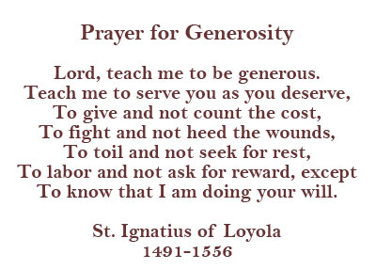
Our Website is:
www.prepase.weebly.com

