**Challenge: (Link: pp. 240-299)**

This Red book is our gift to you. It is important for you to read and reflect on one page a day.

***Link 22: How closely do I want to journey with Jesus?   
Link 23: How ready am I to decide to journey with Jesus?***

***Link 24: How ready am I to be rejected as Jesus was?  
 Link 25: How well do I understand the Eucharist?***

***Link 26: How well do I appreciate the Eucharist?***

***Link 27: How ready am I to say yes to God’s will?***

Note that the specific grace to ask for each week, the suggested daily scriptures, and weekly instructions are listed at the beginning of each week.

**Examen of Consciousness**

St. Ignatius offers this devotion to help review each day.

Find two versions on the Prayer group web site…

Try to get into the habit, and then develop your rhythm.

ATTITUDE OF GRATITUDE

***Daily Grace:*** *(pray this daily!)*

***We ask for the grace to experience overwhelming gratitude for Jesus’ great love for us as he suffers and dies so that we might be united with Him in love, now and for eternity.***

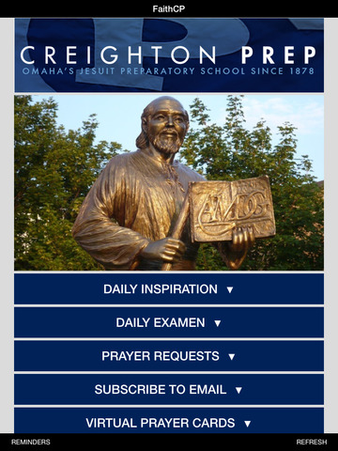

Background information:

(can be found on the website)

* **How do I know I’m experiencing God? (Barry, SJ)**
* **Discerning the Spirits: Setting the Captives Free (Gallagher, SJ)**

Educational & Prayer Guidelines

(can be found on the website)

* *Discernment in a nutshell (Tetlow, SJ)*
* *The Devil comes as an Angel of Light (Barry, SJ)*
* ***Thoughts about making choices (Tetlow, SJ)***
* *Discernment of Spirits (Tetlow, SJ)*
* *Individual’s Election (Tetlow, SJ)*
* ***Rules for discernment (Tetlow, SJ)***
* ***Discernment of Spirits (Spitzer, SJ)***

Intentions: (can be found on the website)

* ***Prayer for Staff, Teachers, Jesuits***
* ***Papal Intentions / Prep Intentions / Birthdays***

Meditations: (can be found on the website)

Within the next month, try to do each of the meditations at least once:

* **Contemplate the Passion**

Jesuit Prayers: (can be found on the website)

Pray when the Spirit leads you.

* ***In the Hands of God***
* ***I Take my Stand on His Word: Psalm 130***
* ***AMDG***

Catholic Devotion:

(can be found on the website)

* ***Lenten Reflections***

***IMPORTANT:***

***These handouts are intended to enrich your experience, not overwhelm you.***

***This is NOT homework!!!***

***It is a variety of materials that represent different means for communicating and drawing closer to Our Lord.***

***We provide a variety of materials as everyone has different spiritual tastes and needs.***

***Choose where the Holy Spirit leads YOU in your life today. Do as much or as little as you can in your busy schedules, and know that God cannot be outdone in love and generosity.***

***He will give back so much more for every moment we spend with Him!***

‘

# AMDG

I am supposed to do everything in life for one reason: the greater glory of God. Yet I spend most of my life unconcerned with this; I waste it on petty things.  
God, please grant me clear vision, the vision to work for the greater glory of your name. Please help me to wake up each morning with this in mind. Help me to clear my mind of minor details that only distract me from my purpose. Keep away the indifference that fogs humankind. Point me where your people need help so that I may go to bed each night knowing the world is a better place, and your vision has been fulfilled.

Kirk Roberts  
Jesuit High School, Tampa, Florida