This month (April)
we celebrate the life and memory of
St. Jose d’Anchieta Llarena, S.J.,
(1534 – 1597);

José de Anchieta Llarena, S.J. was a Spanish Jesuit missionary
to the Portuguese colony of Brazil in the second half of the 16th century.
Often referred to as “the Apostle of Brazil,” Father Anchieta,
like Saint Ignatius, came from the Basque country. He was missioned to the Portuguese colony of Brazil and was one of the founders of both São Paulo and Rio de Janeiro.

Father d’Anchieta is also known as the Father of Brazilian literature. In the tradition of Jesuits, Father d’Anchieta was a prolific rapporteur, communicating by letters to his superiors. He wrote with equal ease in Spanish, Portuguese, Latin and the indigenous language, Tupi. With his book The Art of Grammar, he became the first person to give a written orthography to the Old Tupi language most commonly spoken by the indigenous people of Brazil. It is recognized as the first compilation of an indigenous language made in the Americas.

Anchieta was closely involved in the religious instruction and conversion to the Catholic faith of the Indian population. He was accomplished at singing religious chants and wrote several of them, as well as a drama to teach morals to the Indians by means of music and theater. His efforts at Indian pacification were crucial to the establishment of stable colonial settlements in the colony.

He wrote a poem to Our Lady, and legend has it that he wrote it on wet sand each morning and memorized it until he much later wrote its 4,900 verses (!) on paper.

He was an accomplished musician and dramatist with several published works; he is the patron of literature and music in Brazil. He also managed to be the Jesuit Provincial Superior, a historian, naturalist and an excellent surgeon and physician.

During and after his life, José de Anchieta was considered almost a supernatural being. Many legends formed around him, such as that he once preached and calmed an attacking jaguar. To this day, a popular devotion holds that praying to Anchieta protects against animal attacks.

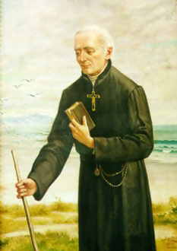
“We have many reasons for being grateful to Pope Francis for placing José de Anchieta before the world as a new and outstanding example of sanctity,” said Jesuit Father General Adolfo Nicolás.

“For the Society of Jesus it is an occasion to renew with intensity the search for those horizons which he pursued and which are always new: sensitivity in the face of ethnic diversity and religious, cultural, and social pluralism; the untiring development of a fresh creative freedom and a responsible capacity for improvisation; the constant search for inculturated expressions of the Christian and evangelizing experience.”

