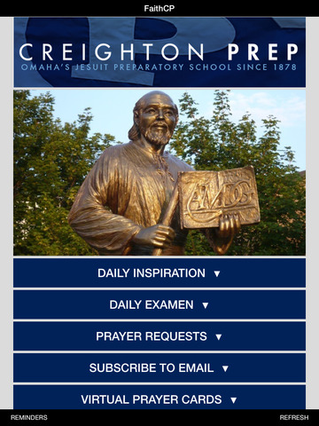

Background information:

(can be found on the website)

* **Ignatian Spirituality Resources for Parents**

Educational & Prayer Guidelines

(can be found on the website)

* ***Praying with Fantasy***
* ***Centering***

Catholic Devotion:

(can be found on the website)

* ***Rosary: St. Ignatius Method***

Intentions: (can be found on the website)

* ***Prayer for Staff, Teachers, Jesuits***
* ***Papal Intentions***
* ***Prep Intentions***
* ***Birthdays***

Meditations: (can be found on the website)

Within the next month, try to do each of the meditations at least once

* *Prayer Before Meditation*

*(Inside Cover of Link book)*

* ***Principle and Foundation***
* ***The Sin of the Angels***
* ***The Sin of Adam and Eve***
* ***The Sin of One Person***
  + ***FYI: Triple Colloquy***
  + ***FYI: Jesus Prayer***

Jesuit Prayers: (can be found on the website)

Pray when the Spirit leads you.

* ***Transformation***
* ***Surrender***
* ***Prayer to Christ Our Model***
* ***You Have Called Me by Name***
* ***What Have I Done for Christ***
* ***Teach Me to Listen***

***Daily Grace:*** *(pray this daily!)*

***We ask for the grace***

***to understand God’s   
unconditional love for us***

***despite our sinfulness.***

**Challenge: (Link: pp. 38-87)**

This Red book is our gift to you. It is important for you to read and reflect on one page a day.

***Link 3: Do I rejoice in who I am?***

***Link 4: How meaningful is my life?***

***Link 5: How real is God for me?***

***Link 6: What is God’s plan for me?***

***Link 7: How open am I to God’s plan for me?***

Note that the specific grace to ask for each week, the suggested daily scriptures, and weekly instructions are listed at the beginning of each week. (pages 49, 59, 69, 79)

**Examen of Consciousness**

St. Ignatius offers this devotion to help review each day.

Find two versions on the Prayer group web site…

Try to get into the habit, and then develop your rhythm.

**First Principle and Foundation**

We are created to praise, reverence, and serve God our Lord, and by this means to save our soul.

All the other things on the face of the earth are created for us that they may help us in accomplishing the end for which we are created.

From this it follows that we are

to use them as much as they help us to this end, and

to rid ourselves of them so far as they hinder us.

For this it is necessary to make ourselves *INDIFFERENT* to all created things in all that is allowed to the choice of our free will and is not prohibited to it;

so that, on our part, we want not

* health rather than sickness,
* riches rather than poverty,
* honor rather than dishonor,
* long rather than short life,
* and so in all the rest;

desiring and choosing only what is most conducive for us to the end for which we are created.



***IMPORTANT:***

***These handouts are intended to enrich your experience, not overwhelm you.***

***This is NOT homework!!!***

***It is a variety of materials that represent different means for communicating and drawing closer to Our Lord.***

***We provide a variety of materials as everyone has different spiritual tastes and needs.***

***Choose where the Holy Spirit leads YOU in your life today. Do as much or as little as you can in your busy schedules, and know that God cannot be outdone in love and generosity.***

***He will give back so much more for every moment we spend with Him!***

**SYNOD OF BISHOPS ON THE FAMILY**

What is a Synod?  
<https://www.youtube.com/watch?v=e3kQeHnDHyc>

What to expect from this synod?

<http://www.catholicnewsagency.com/news/what-to-expect-from-this-years-synod-of-bishops-35141/>

What are the guiding documents?

<http://www.catholicnewsagency.com/news/synod-guiding-document-families-need-the-churchs-message-of-mercy-71531/>

Pope Francis asks for prayers for Synod

<http://www.catholicnewsagency.com/news/pope-francis-asks-for-prayers-ahead-of-synod-discussion-48774/>

The Vatican official website with news.

<http://www.news.va/en>

I hope you enjoy and pray with one another for more peace in the world.