Some Personal Aspects of Teilhard de Chardin’s Thought

Shaking hands with Teilhard
Pierre Teilhard de Chardin, the French Jesuit and paleontologist, died almost aged 74, on Easter Sunday, 1955.That did not give me much chance to meet him, but I feel fortunate at least to have had his second-hand handshake. That is, I have met a person who in turn met Teilhard.
It was when I was nearing the completion of theology studies at Heythrop College, University of London, in the early summer of 1977. I was writing a dissertation comparing the methodology in theology and in science, when one of my mentors suggested that I go down to Wimbledon and interview Father William Cuthbert Donnelly, a Jesuit theologian who had spent the last part of his life teaching at a seminary in Zimbabwe and who was now back in England, but failing in health. And why should I want to see him? Because Cuth, as he was known among Jesuits, had not just met Teilhard, but had worked with him in Rome during 1948 when Teilhard had been asked by the Superior General of the Jesuits to try and make his writings, particularly The Phenomenon of Man, acceptable to the Vatican. They did not succeed, but I remember how Cuth just lit up when I was asking him about this experience.
Cuth could not tell me details of their work together, but he did repeat, “Teilhard had no side on him”. I understood from this that Teilhard, while a consummate teacher, was not trying to force his views on anyone, and so it was easy to work with him. Cuth also indicated that Teilhard was very clear in his understanding of the distinctions between doing science, thinking about philosophy, and reflecting on theology. These disciplines were related certainly, but not to be confused. I have since found this helpful when reading Teilhard’s writings. It is also something that I too have tried to live out as I have done scientific research, enjoyed thinking philosophically, and keep integrating a theological perspective.
I should like now to touch upon those aspects of Teilhard’s thought which have been helpful to me in my own life and ministry as a Jesuit and an astronomer.
Our relationship with the Universe
After theology studies in London, I left for the University of Toronto to begin a doctorate in Astronomy as immediate preparation for joining the staff of the Vatican Observatory. The “UofT” had a premiere Canadian department of Astronomy, and it proved to be a good choice. The courses were wide in scope (pun intended) and helped me reach out to the universe in all its aspects.
Now Teilhard wrote something about our relationship with the Universe that has been often quoted:
"Hitherto, the prevailing view has been that the body . . . is a fragment of the universe, a piece completely detached from the rest and handed over to a spirit that informs it. In future, we shall say that the Body is the very Universality of things....My matter is not a part of the universe that I possess totaliter: it is the totality of the Universe possessed by me partialiter"
The account of the universe that modern astronomy unfolds, from the initial, unimaginably intense radiation in the Big Bang to the emergence of primordial hydrogen and helium, and thence via nuclear synthesis in stars to all the elements we find around us on Earth, makes a fascinating story of how our bodies are literally made up of “stardust”. Our bodies do borrow, partialiter, from the product of the universe. (Partialiter=partly, and totaliter=totally, are Latin technical terms, familiar to Teilhard from the works of St Thomas Aquinas.) It is a “borrowing” since our bodies undergo a complete change of their individual atoms every seven years. We and the Universe are truly one…and yet Teilhard understood that there is so much more to us than seeing ourselves as just a mass of atoms. Everything, including the very “mass” of our bodies, is a shining forth, or diaphany, of spirit, and wondrously of that same Spirit through which the Body of Christ shines forth in the celebration of every “Mass”.
The Mass on the World
The University of Toronto had telescopes both nearby just north of Toronto and one down in Chile. The latter, though on the small side, was in a perfect observing site and well-equipped. This telescope turned into a “thesis-saver” when my original dissertation topic became stalled by the bad weather that I experienced in South Africa. The UofT’s telescope was located at Las Campanas in the Atacama Desert, a place even drier than the steppes of Asia in which Teilhard composed “The Mass on the World”. From my time in that desert, I am not at all surprised that “The Mass” was a favourite of the lady who arranged for the posthumous publication of Teilhard’s writings and knew him so well, Mlle Jeanne Mortier (Thomas King, Teilhard’s Mass, New Jersey: Paulist Press,2005, p. ix). When Teilhard offered on the altar of the whole Earth “all the labours and sufferings of the world”, I could resonate with my own offering of the work of observing along with the frustration of cloudy nights, particularly those experienced earlier in South Africa. The symbolism of the bread, which is our constructive toil, and the wine, our pain, is very immediate to our experience, but especially so when these are transformed by the…
"Radiant Word…through which all our…encounter with the universe are come together into a unity. Over every living thing which is to spring up, to grow, to flower, to ripen during this day say again the words: This is my Body. And over every death-force which waits in readiness to corrode, to wither, to cut down, speak again your commanding words which express the supreme mystery of faith: This is my Blood
When people ask me how it can be that my principal priestly work is to do astronomy, then this vision of Teilhard, that integrates the action of the Mass with the whole of our human experience, helps explain why. Indeed, Teilhard described every scientist as a sort of priest, for
“every work of discovery in the service of Christ, which thus hastens the growth of his mystical body, shares in his universal priesthood”.
The Heart of the World
In talks that bring in the idea of the interaction of matter and energy I have often used a quote from Teilhard, “At the heart of Matter, a World-Heart, the Heart of a God” (Introduction to The Heart of Matter, New York: Harcourt Brace Jovanovich, 1978, p.15). What struck me about this was that Teilhard saw matter as dynamic. A stone is not just resting there on the ground; it is filled with energy, with activity, since it is made up of far-from-static atoms. The source of that energy is Christ, the personal heart of the cosmos. Christ is also its ultimate unity and goal, the Omega Point.
With this dynamic viewpoint I was very open during my doctoral studies to a suggestion from an astronomy colleague that, now I was in Toronto and relatively close to New England, it was time I came to an annual conference of the Institute on Religion in an Age of Science (IRAS) on the appropriately named, Star Island, New Hampshire. I was happy to find myself surrounded for a week by people who took evolution seriously, and so attending that annual meeting has become regular for me.
Evolution is not confined to the discipline of astronomy. It includes all the aspects that make up the Big History of the Universe: geology, biology, paleontology, anthropology, environmental studies, economics, etc., as well as standard history. Teilhard himself took part in the discovery of Peking Man, an example of Homo erectus, dating roughly to ¾ million years ago. H. erectus was well on the way to understanding and mastering his environment. He was fully bipedal and an excellent big game hunter. Later members of the genus Homo, including our own species, Homo sapiens, are now believed to have evolved in Africa, and not directly from H erectus. For the beginnings of what we call human sentience, that is, the ability to feel and perceive in a human way, archaeologists have returned to Africa and to the Middle Stone Age to discover the first remnants of religion, art, and even greater mastery of their environment among hominins who were closer than H. erectus to a direct line to modern man.
Interconnectedness
Our human sentience clearly has evolved, and will continue to do so. As it does, we come to reflect more critically on the interconnectedness of everything within the universe.
"In every field we will begin to live constantly in the presence and with the thought of the Whole. There is nothing more capital, from the point of view of human Energy, than the spontaneous appearance and ultimately, the systematic cultivation of a “cosmic sense” of this kind. Through such a sense, Men cease to be self-contained individuals, and make a common cause"
Teilhard would recognise that with the growing sense of the interdependence of all life forms comes a responsibility. It is a responsibility not just for human progress, but for the progress of the entire ecosystem in which we exist, which sustains us, and which shares in the full evolutionary story, the Big History. While Teilhard served as a stretcher-bearer during the First World War, he experienced in the trenches the camaraderie that a common cause will bring. A similar, intense camaraderie is needed today to tackle environmental destruction and the abuse of the World’s limited resources. Teilhard’s vision of the energy and unity of all “matter” is something that could be most helpful to achieve the level of commitment needed by everyone, not just the current, ecologically-sensitive few.
Finding Wholeness
Teilhard’s thought and spirituality are so rich that I am only able to touch on a small part of them. My selection comes from aspects that have been and remain helpful to me as a Jesuit priest and astronomer for the Vatican Observatory. These aspects have particularly dealt with the interpenetration of matter with spirit. It is this interpenetration that makes the work I do as an astronomer, even the tedious parts, totally spiritual while also totally material. They form an element of the progress of the Universe, human and everything else, into the Whole, which is Christ.
Father Cuth Donnelly ended my interview with him by saying about Teilhard, “Yes, he was a great man. It was a privilege to know him.” My aim has been to help you also know Teilhard a bit better; and I hope you are encouraged to make your own selection from his writings, so that you too can find a vision that sustains everything you encounter, both now and into the future.
Fr Christopher Corbally SJ, Vatican Observatory
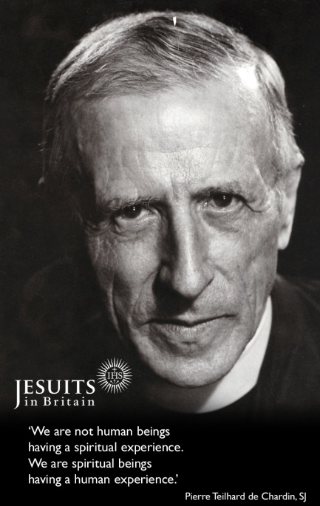
Fr Pierre Teilhard de Chardin SJ
Born: 1st of May 1881
Entered the Society: 1st of September 1899
Ordained: 24th of August 1911
Died: 10th of April 1955

