"Contrary to the advice of all the white people in the fort I went to meet them. They received me with unmistakable tokens of friendship and respect… The great Chiefs spoke favourably with regard to peace, and heard with pleasure and satisfaction the words I addressed them."

Fr Pierre-Jean de Smet SJ
Pierre Jean de Smet (1801-1873) was born in Belgium, but as a young man he travelled to Baltimore in north America and entered the newly-restored Society of Jesus in 1821. He asked to be allowed to work with the native people of the New World and to meet and work with native communities. He made a number of expeditions through the unchartered regions of the continent and assisted in the first mapping of the Missouri river system. As one of the Jesuit ‘Blackrobes’, de Smet came to be trusted by many native tribes such as the Sioux, the Iroquois and the Flatheads. He was appalled at the brutality and violence and tried to protect the native Americans from this invasion into their culture. In a time of great instability and war, he visited Chief Sitting Bull and managed to persuade him to enter peace-treaty negotiations. In all de Smet is estimated to have travelled more than 180,000 miles around America and made many sea-journeys back to Europe to raise funds for the ministry to the native Americans. Among his many achievements he helped to establish St Louis University. Historians of the Jesuit missions in the Americas have tended to focus on the heroic exploits of the missionaries in Canada and in Paraguay, but there are many Jesuit stories from the New World. This is the story of an enthusiastic young Belgian just out of his teens who left family and homeland to ‘go among the Indians’ of North America and who spent the rest of his life in their service. What he could not have foreseen was that all his efforts to defend their rights and to preserve their way of life would ultimately be in vain. In his lifetime, he was an apostle of peace, reconciling the tribes with one another, negotiating treaties with the US government and always proclaiming the Gospel in word and in deed wherever he was sent.
Peter John De Smet was born in Dendermonde in the Flemish part of what is now Belgium on 30 January 1801. His father was the owner of a ship-outfitting business whose fortunes had prospered during this period of Napoleon’s wars and young Peter (to give him the English name by which he would be known in later life) grew up in the sight of ships and the shipping trade. His mother was gentle and loving; his father was loving and strict. The family atmosphere was one of traditional Catholic piety. The boy grew up strong, lively and devout. Eventually, he was enrolled in a school in Mechelen which served as a preparatory seminary, and it was while he was there that his beloved mother died. He was 18. In 1821, inspired by the preaching of a visiting Jesuit missionary who was known as the Apostle of Kentucky, he found his vocation. Together with several other students, he prepared to leave for America under the auspices of some of the college Fathers. His own father discovered this plot and sent Peter’s older brother Charles to intercept him before he could reach Amsterdam and ships bound for America. So, far from dissuading Peter from his adventure, Charles ended up giving him money and wishing him God’s blessing. Peter’s father died in 1827 without ever seeing his son again.
Peter joined the Jesuit novitiate at White Marsh in Maryland and remained there until 1823. At the prompting of the US government, the Society of Jesus opened a mission at Florissant near St Louis, Missouri, and it was there that Peter was sent after taking his vows with the intention of working among the Native American tribes in the region. As he was among the first Jesuits to establish this mission, Peter De Smet is considered a co-founder of the Missouri Province of the Society of Jesus. He would remain at Florissant until 1833. It was the era of President Andrew Jackson and a new stage in the development of the Republic. After a return visit to his homeland, the new priest made his first tour of the interior of the country to the west, establishing in 1837 St Joseph’s Mission at Council Bluffs for the benefit of the Potawatomis. It was then that he went among the Sioux for the first time, in order to arrange a peace between the two tribes – the first of his many peace missions. 1840 saw the real start of his life’s work as he ventured north-west to the Flathead tribes. As early as 1831, some of the Native Americans of the Rocky Mountains had arrived in St Louis where they asked for ‘Black-robes’ to be sent to them. Influenced by Iroqouis who had descended from converts made by the French missionaries of the 17th century, the Flatheads continued to send delegations to St Louis until finally, in 1840, De Smet was missioned to the Rocky Mountains to explore this possible mission field.
He set out on a journey through largely uncharted wilderness and was eventually welcomed by the Flathead people, whom he got to know. On his return journey to St Louis, he visited other tribes, including the Crows and the Gros Ventres. In all he covered 4,814 miles. At St Louis, after giving his report, he was charged with establishing permanent missions in the North West. Together with Fr Nicholas Point he founded St Mary’s Mission on the Bitterroot River, 30 miles north of Missoula (Montana), adding the Coeur d’Alene tribe to his apostolic family. De Smet conceived at this time the possibility of founding ‘reductions’ for the American Indians along the lines of the experiments in community life made by the Jesuit missionaries to Paraguay in the preceding century. These communities would provide a settled base for the tribes and enable them to experience the benefits of civilisation (conceived in European terms), while carrying on traditional pursuits and livelihoods. They would help to ensure peace between the tribes and to legitimise their claims on territory already under threat from the westward expansion of the American whites.
In order to realise this vision, resources would be needed. De Smet therefore returned to Europe in 1843 to acquire funds and volunteers. In 1844, he made a remarkable voyage to the west coast of Canada aboard the ‘Infatigable’, rounding the southern tip of South America. With him were six sisters of the congregation of Notre Dame de Namur and other volunteers. After conferring with the regional bishop, he established the mission station of St Ignatius, near the mouth of the Columbia river (British Columbia), in order to serve the Kalispels of the Bay. At this time, De Smet became increasingly concerned about the Blackfeet, a warrior tribe who were a constant menace to their neighbours. In 1846, following a battle between the Blackfeet and the Crows, he decided to appeal personally to the Blackfeet and after meeting with them in Yellowstone Valley, he accompanied the chiefs to Fort Lewis where peace treaties with the other tribes were concluded.
During his years in the wilds, De Smet lived the classic life of a missionary explorer. He endured incredible hardship, relying on basic survival skills to deal with the terrain, the climate and the wildlife. He also had to deal with the attendant emotional and psychological stress of such a way of life. In his interaction with Native Americans he constantly needed interpreters in order to communicate – an added frustration. Nevertheless, it is evident that his personal presence had a powerful and positive effect on those around him; and although he might have felt himself to be in danger from time to time among unknown and potentially hostile peoples, he seems never to have been treated with violence of any kind. On the contrary, he appears to have been welcomed and trusted wherever he went.
Throughout his travels De Smet wrote many letters and kept journals. He had a gift for lively prose and he was soon able to get his writings published. These were met by an eager market in Europe and in the United States. The name of Peter De Smet became known by all who took an interest in the American West and in the way of life of the Native tribes. He might have ‘retired’ from active duty at this point in his life, but providential circumstances were to call him into an even more public role.
The growing movement of white settlers across the Plains on their way to the California and Oregon territories was causing increasing alarm among the Native Americans and increasing hostilities between them and the settlers. In 1851, a ‘general congress of the Tribes’ was summoned by the US government with a view to establishing the conditions for peace. The congress would assemble in Horse Creek Valley near Fort Laramie (Wyoming). The government, having been impressed by De Smet’s reputation as a negotiator among the Indians, requested his assistance. His superiors acceded to the request and he made the long journey from St Louis. The 10,000 Native Americans gathered at this place came, as it was said, ‘under his spell’ and treaties were duly signed. As a result of this success, the government requested that De Smet be commissioned as chaplain to the US Army (in which there were considerable numbers of Catholics) so that he might help defuse the many critical situations that were arising in the course of the westward expansion of white Americans. In 1858, he was asked to mediate a dispute with the Mormons, who were refusing to accept a governor in Utah. He accompanied General Harney on this expedition and, although the dispute was settled before their intervention was needed, the priest and the General had developed a good relationship. De Smet was invited to deploy his peace-making skills among the tribes of the Oregon and Washington territories who were becoming increasingly nervous of the threat to their lands and their way of life. He carried out this assignment as best he could until the increasing likelihood of a war between the Northern and Southern States made it necessary for him to resign his commission. Missouri was a ‘border state’ – aligned with the Union but legally permitting slavery. Like most Jesuits he was forced to remain outwardly neutral during the War, while inwardly sympathising with the abolitionist cause. The War itself gave an opportunity for some of the tribes to re-assert their rights and, in 1862, a Sioux uprising led to a punitive expedition by the Union Army. De Smet had worked among the Sioux in the preceding year at the request of the Jesuit Superior General, but he refused the government invitation to be a part of such an expedition.
The years following the Civil War saw the great tragedy of the American Indian unfold, as the United States continued to grow and the white population began to settle on all available lands. The pioneer families, in no doubt as to their entitlements over the virgin territories of the American west, were in continual conflict with the indigenous peoples and there was equal courage and determination on both sides. Unfortunately, the Native Americans were not in a winning position. Treaties were made and then broken. The Indians came to distrust every promise made by the whites. In this poisoned atmosphere, De Smet himself could do little. He was called in 1867 to represent the government Peace Commission to the Indians and, on yet another tour of the Plains and the North West, he spoke with thousands of Native Americans on behalf of the government’s proposals for tribal homelands and peaceful cohabitation. By 1868, he had crossed the Bad Lands to reach the main camp of the redoubtable Sioux at Powder River and, in the presence of 5,000 members of that tribe he met with Chief Sitting Bull. The Chief was (rightly) sceptical, but treaties were again concluded. The ‘Indian Wars’, however, did not come to an end and, in 1870, De Smet was again in negotiations with the Sioux. By this time he had come to see that the government, for all its good intentions, was unable to prevent the white settlers from taking whatever lands they were able to. The Peace Mission was a doomed effort. In fact, some 500 treaties were made with the Indians over a period extending from the foundation of the United States until the early years of the 20th century. All were ultimately broken. De Smet died at St Louis on 23 May 1873.
Fr Peter De Smet was a Jesuit with great qualities and a hero in the classic missionary mould. Although occasionally in trouble with his own colleagues about the use of funds and about his own somewhat independent style of operation, he was acknowledged by his peers to be a model of the vows. He possessed a child-like cheerfulness in the face of every adversity. In his tireless efforts for peace, he relied entirely on Faith, Hope and Charity to achieve the impossible. His was a delicate balance between the interests of the Native Americans, the interests of the American Republic and the interests of the Catholic Church. To this must be added his first and greatest concern: to make known the Gospel of Christ. In the service of this calling, he travelled 180,000 miles and devoted every waking moment of his life.
Fr William Pearsall SJ

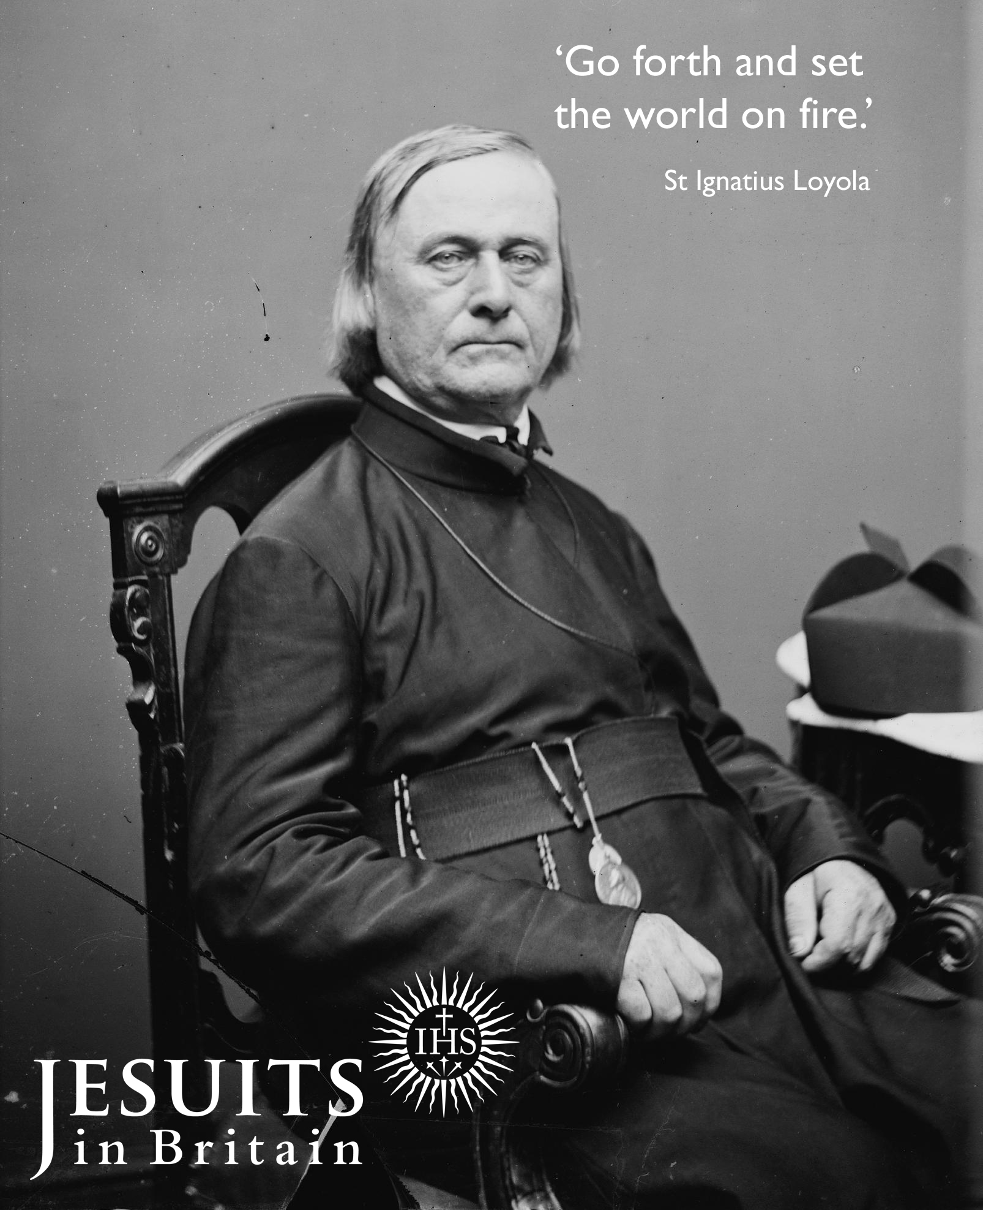

Born: 30th of January 1801
Entered the Society: 1821 in Baltimore, Md
Ordained: 23rd of September 1827
Died: 23rd of May 1873

