Catholic Traditions: Novenas

What is a Novena?
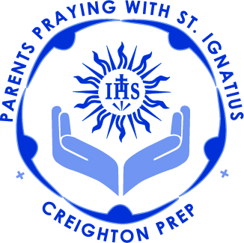
A novena is a series of prayers that are said for nine straight days, usually as a prayer of petition but sometimes as a prayer of thanksgiving. The nine days recall the nine days that the Apostles and the Blessed Virgin Mary spent in prayer between Ascension Thursday and Pentecost Sunday. Though the word novena comes from the Latin novem, meaning "nine," the term has also come to be used generically to refer to any lengthy series of prayers. Thus, the Saint Andrew Christmas Novena is recited for more than nine days, between the Feast of St. Andrew on Nov. 30 and Christmas. Every year, we pray the Divine Mercy Novena on the nine days between Good Friday and Divine Mercy Sunday.

There are four main types of novenas (a novena may fit into more than one category):
- novenas of mourning, such as the novena made during the novemdiales -- the nine day period following the death of a Pope
- novenas of preparation, or "anticipation," such as the Christmas or Easter Novenas
- novenas of prayer
- the indulgenced novenas

In some novenas, the same prayer is said each day for nine days, or sometimes 9 times in one day; others may have (or add) different prayers for each of the 9 prayer sessions. Be aware that some uneducated persons think about Novenas in a superstitious manner. Any Novena instructions that include words such as, "say this prayer for 9 consecutive days and your wish will be granted to you," or that describe the Novena as "never fail" in would lead one to believe that God is at our beck and call rather than our being His humble servants.
Novena for November and December

Novena for the Deceased

God, You are the Creator and Redeemer of all the faithful, grant to the souls of your servants the remission of all their sins, that through our sincere prayers they may obtain the pardon they have always desired. Through Christ, our Lord, Amen. Lord, God, by the Precious Blood which Your divine Son, Jesus, shed in the garden, deliver the souls in purgatory, especially those who are the most forsaken of all. Bring them into Your glory, where they may praise and bless You forever. Amen.
(Our Father, Hail Mary)
Eternal rest grant unto them, O Lord, and let perpetual light shine upon them.
May they rest in peace. Amen
May their souls and the souls of all the faithful departed, through the mercy of God, rest in peace. Amen

Christmas Novena (St. Andrew Novena)
Say 15 times a day from St. Andrew's Day (30 November), ending on Christmas Eve

Hail, and blessed be the hour and moment at which the Son of God was born of a most pure Virgin at a stable at midnight in Bethlehem in the piercing cold. At that hour vouchsafe, I beseech Thee, to hear my prayers and grant my desires. (Mention your intentions here) Through Jesus Christ and His most Blessed Mother. Amen

