6:45 Greeter:
6:50 Quiet Settling with Soft Music
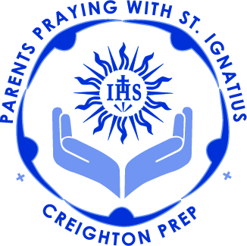
7:00 Call to Prayer (Mark Link, SJ): Volunteers
7:03 Review of Examen and Colloquy.
7:15 Sharing of Week 3: Reflection Questions: Parents in small groups
7:25 Scriptural Reading to Close Week 3 of the Spiritual Exercises:
7:29 Introduction of Guest Speaker:
7:30 Mr. Andrew Cera, nSJ, Social Studies Department
7:50 Teaching: Fr. Schneider, SJ
Paschal Mystery
Holy Week & Easter
The transition from Phase 3 into Phase 4 of the Spiritual Exercises Retreat.
Meditation for Holy Week

8:10 Handouts Distributed and Link Readings Overview: WHO?
Monthly Link Readings and Meditations
Week/Phase 3 Scriptural Readings
Examen and Colloquy sheets…

8:15 Intentions:
8:25 Announcements:
Interest in Leadership roles

BASH fast approaching-if you attend please check out the PPWI baskets.

April 26th 3:00pm on Memorial Plaza, west side of Prep: End of Year Rosary for Prep Community especially graduating seniors

May 8, 2017: Last PPWI gathering of this year, Celebrating 10 years: Mass with Fr. Kevin in Prep Chapel
followed by end-of-year celebration in the Creighton Room

8:28 Call to Mission (Mark Link, SJ): Volunteers

