A Man of Peace: Fr. Frans van der Lugt, SJ byTONY HOMSY, SJ April 8, 2014

When I woke up Monday morning, I went directly to check my emails, all the media were talking about the assassination of Father Frans van der Lugt, S.J. On the morning of 7 April 2014, he was “abducted by masked gunmen from [his] residence at Homs, in Syria, where he used to live, and was executed by gun shots…Despite the dangers, he had voluntarily decided to remain in the city of Homs in solidarity with the people who could not leave the city. He remains in our thoughts and prayers.” Outside of Syria, “Frans” – as we preferred to call him – was not a household name like Fr. Kolvenbach – another great Dutch missionary from my own native Middle-East Province who served the Society of Jesus as its Superior General. Yet, people who knew him knew the simple, generous, and loving man that he was. Part of me was trying to celebrate Frans as one who devoted his life for a purpose, and he has now just fulfilled it. But another part of me is heartbroken at losing a great companion, a Jesuit who inspired all of Syrian Jesuits through the last decades.
In recent years, Frans was deeply involved with the ongoing conflict in Syria. The Erasmus blog at the Economist recognized his life of service in a post from 10 February by noting Frans’s desire to alert “world opinion to the plight of people in Homs.”2 On 8 April, the day after Frans was killed, Erasmus quoted another Jesuit, Jan Stuyt called Frans a “martyr for inter-religious dialogue.” Erasmus writes beautifully about the impact that Fr. Frans had, both in life and in his death:
By staying in the heart of besieged Homs, during a takeover by rebels who included militant Islamists and then during a government siege, he was offering succour to all victims of the conflict–and a kind of reproach to all the belligerents. He knowingly risked his life by remaining in a place where some Islamist rebels were active; but he also bore witnesses to the cruel consequences of the siege by refusing to leave when it was would have been so easy to do so, and nobody would have blamed him. From the perspective he offered, all civilian victims were worthy of compassion, and fighters on both sides bore a share of blame. That sounds like a truth worth dying for – and it goes a bit further than religious dialogue.3
I was blessed to share the same building for the last two years of my time in Beirut with Father Kolvenbach. But with Frans, I shared a lot more. My relationship with Frans began during my journey to join the Society of Jesus and he was the delegate of the provincial the day I entered…
But how was it possible for a foreigner – Dutch in Syria – to win the hearts of all Syrians, be they Christian or Muslim, Pro-regime or opposition. A few members of his community, when they left the Old City of Homs, said about him, “We won’t survive without Abuna (Father) Frans.” How is this possible, you ask? Because Frans knew the keys to being a good missionary. As I’ve reflected on my own experience of Frans,
Just a few days before his death, Frans posted these lines on a Facebook page he used to spread news:
“Christians in Old Homs are asking themselves: “What can we do? we can’t do anything!” But God will take care of us; we are paralyzed, though we believe that God is with us, especially in these taught circumstances… God will never forsake us, he knows us, and knows our suffering, he never wanted any evil. All he has is a compassionate look toward his beloved…
Our faith helps us a lot to overcome this critical situation, provides us with hope and patience… But it is getting harder and harder, and our ability is getting narrower… Starving is threatening our lives, we miss the basic elements to survive, food and elementary needs…
But somehow we are surviving, and push life forward. Moreover, we experience the goodness of people who are in need. They find some lentils and bulgur (all they can people eat after two years) in front of their doors. Now, when we are poor and in need, we rediscover the goodness of human beings, when we receive from our brothers and sisters. We see evil is trying to find his way among us, but it can’t turn us blind before the goodness, and we need to fight to keep this flame in our hearts… We are waiting the result of the negotiations, we are optimistic that they can find a solution for us, but time has taught us not to believe rumors…
We are preparing ourselves to Easter, reflecting on crossing from death to resurrection. We feel like we are in the valley of the shadows, but we can see that light far away, leading us to life again…We hope that Syria experience resurrection soon again… and Let’s move forward”.
I’ve found three central characteristics that both helped him thrive as a leader and a missionary, as well as a minister of the Gospel. *
- Generosity:
Frans gave freely of himself to everyone he met and was like a father to us all – Jesuit and lay alike. He gave to the point that I’ve heard some Jesuits grumble about how he didn’t care enough for himself. When he was on retreats, he would spend the whole night listening to confessions and giving spiritual advice or just listening. And then, he still got up early in the morning to start his Zen meditation.

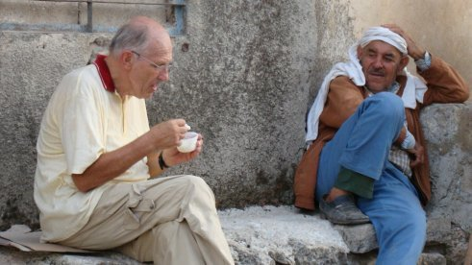

- Love:
Many Jesuits are famous for their lectures that they hold in the local churches, and Frans was no exception. But there is something special about how Frans did it. Because he had immersed himself in the culture and the language and he knows the daily details of Syria, he spoke with an authentic voice of Love. He attracted the youth to his lectures and preaching by speaking about Love. But what attracted all of us was his life itself: a life of love. This Love invited him to find joy in being Syrian…even more than being Dutch, as he used to say. I won’t forget the day, when I tried to explain a joke that I had made (in a slang Syrian accent), he interrupted me:
- “Hey boy, how old are you?”
- I replied 23 years old…
- He continued: Ok, I have 19 years more than you in Syria!!!
- Simplicity:
Whoever joined Frans on the hiking trips he used to organize – perhaps what he is famous for more than being a Jesuit missionary – would see that this old man survived on basic, simple food. Meanwhile all of us were dreaming of the when we would go back home and enjoy our mom’s delicious Syrian meals. Yet Frans was happy eating simply. Instead of traveling by car, he crossed the narrow roads of Homs, just like many of the people of that city (though, maybe even more skillfully!) on his bike.
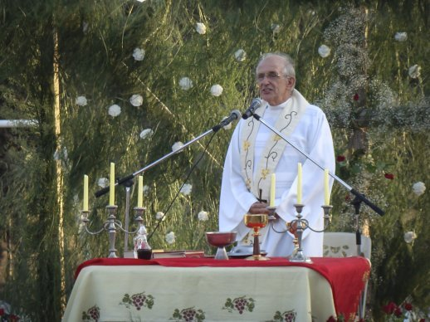

***
I miss you Frans. Last night I looked insanely through my archive for a photo of you and me, which forced me to skim all photos I had taken at different Jesuit events the last five years. You were always there with your smile, and your support. I can see you at their final vows, ordinations, conferences and birthdays… I reached my first vows photos, you were there for sure, in the back seats with your red shirt. You never missed the chance, generation after another to inspire Syrian Jesuits to continue their journey. I realized then that you will always stay with us, as you had been. I can hear you, now in the midst of my course, saying to me: “Move forward, Tony, and continue the work of the church in Syria.”
I will try, Frans. But even though I am young, I still only have a little bit of your energy.

