Jesus in the Gospels and the Eucharist
Something to think about | The Eucharist is the center of my life. I cannot imagine a day without the celebration of the Eucharistic Sacrifice. But it is evident that there is a relationship with the Gospels. We find in the Gospels a realistic, historical image of Jesus as he lived in Palestine. And in the Eucharist we find Jesus Christ living today among us. In neither case can we see him with our own eyes, but the story of the Gospels is the word of God. With strong impact it communicates to us the vital meaning of that word. By reading the Gospels we perceive this Jesus of two thousand years ago as living and very near to us. It is as if Jesus of Nazareth continues to live as he lived in former days. On the other hand, the Eucharist is the body and blood of Christ risen, living, present, although he is hidden under the appearances of bread and wine. He makes himself present, he speaks to us, he inspires us, and he gives us strength.
Pedro Arrupe, S.J.

Remember How Much I Love You. Lisa Kelly
It is the night of the Passover meal, the night before
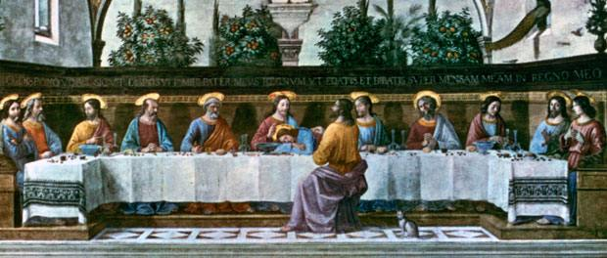
your death. You are not the calm, controlled, repetitive
voice we hear each week at Mass. You are desperate, eager,
attentive, and emotional. You say, “You have no idea how
much I have looked forward to eating this meal with you.”

You are with your closest companions for the last time as
one of them. You are desperate to be assured they get it,
that they understand all you have tried to teach them.
You have been with them day in and day out for three years. You know the road ahead will not be easy for them without you. But most of all, you want them to know how much you love them.

You have nothing to give them—no estate to pass on to them as your heirs, no trust fund to leave them financially secure, and no earthly kingdom or dynasty. After 33 years on this earth, you amassed no material wealth. You even had to borrow the donkey to get there that night. You have nothing to give away to your closest friends. Nothing—except this: this loaf of bread and this jug of wine.

On the night before you die, material wealth no longer matters to anyone. The only thing that matters is having your loved ones near and being sure they know how much you love them.

And you take that bread and wine, and you break it and share it and give it away. You give away all that you have left, as if saying in one desperate plea, “Please, please, in this gift, see how much I love you. It’s all I have left, but more than anything I want you to have it. I want you to remember me by it. I want you to remember how much I love you.”

I want you to remember how much I love you. This is your last will and testament to each of us.

