6:55 Soft Music
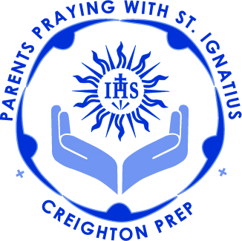
7:00 Call to Prayer; Mark Link, SJ
7:05 Context of Retreat (Fr. Kevin)
Web Experience
Explanation of handouts
7:15 Meditation : (Fr. Kevin)
What are they?
1st Principle & Foundation
7:35 Intentions with Birthdays
7:45 Speaker: Fr. Tom Neitzke, SJ
Questions / Answers
8:25 Review
8:30 Prayer for Generosity
Call to Mission: Mark Link, SJ

The Triple Colloquy
If you remember, the colloquy is a conversation. It might help to picture yourself sitting with the one you are talking to, or walking along together, but deep in verbal (or written) communication.
The Triple Colloquy deals with a specific order of persons you are to talk with.
First, talk with Mary, the Mother of Jesus. Talk to her as you would your own mother, for she is the Mother of us all. Ask her for the graces you are praying for, that she might help you reach them through Her Son and the Father.
Then, with Mary, go to Jesus Christ and talk with Him. There, with the support of Mary, ask Jesus for the same graces and ask Him to accompany you, with Mary, as you finally approach the Father.
Come into God’s presence and feel His love flowing through you. With Mary and Mother, and Jesus the Son, ask the Father for the same graces you have been praying for, that He, Himself, the eternal Lord of all, may give them to me.
End the colloquy as you always end your prayer time, with the Our Father.

