7:00 Call to Prayer: Mark
7:03 Reflect on Sunday’s Gospel
Share with Group: Mark

7:13 Teaching for Phase 4 of retreat & MTGL: Fr. Kevin
7:30 Teaching on Newest Saint and Newest Martyr: Fr. Kevin
7:55 Faculty Guest: Mr. Russell Walter
8:15 Intentions: Jeanne
8:23 Announcements : Lisa
Faculty / Staff Prayer Reminder
BASH basket: Present … Sell!!!
Leaders for Next Year… Interested?…
This Semester dates: Meeting is 5/13 (Mass & Social)
The Rosary is
- April 30 (Wed) @ 3pm @ Prep, West Commons Entrance
8:27 Review: Lisa
8:29 Call to mission & Prayer for Generosity: Mark
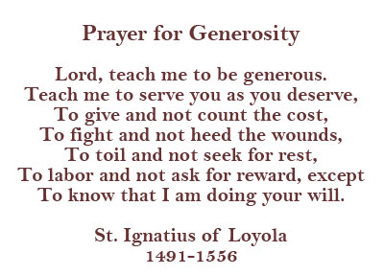
Our Website is:
www.prepase.weebly.com/April

