6:55 Soft Music
7:00 Call to Prayer; Mark Link, SJ
7:02 Read and reflect on Sunday Gospel: Mt 4: 18-23
And large group sharing
7:15 Explanation of phase 2b of retreat: Fr. Kevin
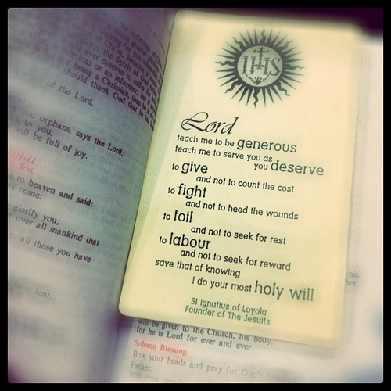
Transition to deeper relationship with Jesus
7:30 Guided Meditation: Call of Apostles
Small group sharing
7:55 Speaker: Fr. Bob Tillman, SJ
8:10 Announcements
Faculty / Staff Prayer (Fr. Kevin)
BASH basket (Lisa)
Freshman Retreat Rosary (Mark)
This Semester dates: Meetings are 2/18, 3/18, 4/15, 5/13
The Two Rosaries are
- Feb 6 (Thur) @ 6pm @ St. Margaret Mary’s Church
- April 30 (Wed) @ 3pm @ Prep, West Commons Entrance
8:25 Petitions
8:27 Review
8:29 Call to mission & Prayer for Generosity
Our Website is: www.prepase.weebly.com/January

