Mark is the host 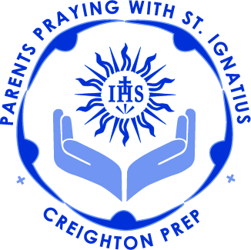

7:00 Call to Prayer/Advent Prayer – Lisa

7:05 Blessing Christmas gifts/Advent Wreath - Fr. Kevin

7:15 Sharing:
- What are three things in my life for which I am most grateful? Why these?

7:25 Teaching on Phase 2-A of retreat – Fr. Kevin

7:30 Imaginative Contemplation: - Fr. Kevin

7:45 Guest Speaker: Mr. Wolfe, SJ

8:05 Advent Teen prayer – Tom

8:10 Intentions Sandi

8:15 Review – Fr. Kevin

8:20 Call to Mission – Lisa

Question for the month:

What does “the Word was made flesh and dwelt among us” mean to me!

St. Ignatius, Pray for us.

