**Challenge: (Link: pp. 140-190)**

This Red book is our gift to you. It is important for you to read and reflect on one page a day.

***Link 13: Why did Jesus live among us?  
Link 14: How did Jesus differ from the other leaders?  
Link 15: Why did Jesus embrace the lifestyle he did?  
 Link 16: How free am I to follow Jesus?  
Link 17: Why did Jesus submit to baptism and temptation***

Note that the specific grace to ask for each week, the suggested daily scriptures, and weekly instructions are listed at the beginning of each week. (pages 149, 159, 169, 179, 189)

***Daily Grace:*** *(pray this daily!)*

***We ask for the grace to experience and to respond to God’s great love for each one of us as we contemplate the life of Jesus.***

**Examen of Consciousness**

St. Ignatius offers this devotion to help review each day.

Find two versions on the Prayer group web site…

Try to get into the habit, and then develop your rhythm.

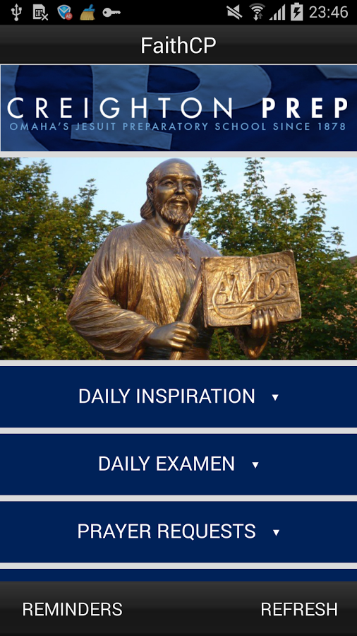 

Meditations: (can be found on the website)

Within the next month, try to do each of the meditations at least once

* *The Kingdom*
* *Contemplate the Incarnation*
* *The Birth of Jesus*
* *Two Standards & Two value systems*
* *Three Couples*
  + ***FYI: Triple Colloquy***
  + ***FYI: Jesus Prayer***

Jesuit Prayers: (can be found on the website)

Pray when the Spirit leads you.

* ***Prayer for what I need***
* ***Eternal Lord of All Things***
* ***Prayer before reading Scripture***
* ***The Prayer of a First Jesuit***

Background information:

(can be found on the website)

* **Ignatian Spirituality and Why we should pray for others**

Educational & Prayer Guidelines

(can be found on the website)

* ***A Frame of Contemplation***
* ***Thoughts about making choices***
* ***Listening to the Spirit***

Catholic Devotion:

(can be found on the website)

* ***The Great “O” Antiphons***

Intentions: (can be found on the website)

* ***Prayer for Staff, Teachers, Jesuits***
* ***Papal Intentions***
* ***Prep Intentions***
* ***Birthdays***

The Link for the Official Vatican page for the Jubilee Year (below) keeps us updated.

<http://www.im.va/content/gdm/en.html>

How can we show others the mercy of God? We say that God is compassionate, but we ignore the poor. We say that God loves us and has mercy on us, but we hold grudges against our friends. Our actions need to authentically reflect God's mercy. Go to the link below to explore the different ways that the USCCB suggest you can live out that mercy every day!

<http://wwwmigrate.usccb.org/beliefs-and-teachings/how-we-teach/new-evangelization/jubilee-of-mercy/>



***IMPORTANT:***

***These handouts are intended to enrich your experience, not overwhelm you. This is NOT homework!!!***

***It is a variety of materials that represent different means for communicating and drawing closer to Our Lord.***

***We provide a variety of materials as everyone has different spiritual tastes and needs.***

***Choose where the Holy Spirit leads YOU in your life today. Do as much or as little as you can in your busy schedules, and know that God cannot be outdone in love and generosity.***

***He will give back so much more for every moment we spend with Him!***

# What the Spiritual Exercises Taught Me about the Incarnation

The Incarnation gets me deep down in my core and it stirs intense emotions within me of awe, joy, and gratitude that occasionally bring tears to my eyes. I believe St. Ignatius would call this, “the gift of tears”: tears that come not from sadness, but because we have touched something meaningful and profound. Tears that help us know we are touching on something important that God yearns for us to understand.

What is it that wells up within me as I ponder the Incarnation? It is the fact that “the Word became flesh and made his dwelling among us” (John 1:14). The Spiritual Exercises helped me understand what this means. God took flesh in human form not as a man, but as a newborn child—a child that was conceived by the Holy Spirit and placed [**into the arms of his mother, Mary**](http://www.ignatianspirituality.com/11555/mary-receiving-jesus-into-her-arms/), and gazed upon proudly by his father, Joseph.

What would our lives be like if God had not become flesh? What would our lives be like if Jesus had not come into our world? I shudder to think of the darkness and lack of hope in our lives.

Jesus came, though, and brought light to overcome all darkness in our world. The [**Spiritual Exercises**](http://www.ignatianspirituality.com/ignatian-prayer/the-spiritual-exercises/) helped me understand the Incarnation because Jesus, who came into this world as a newborn child, left our world sacrificing his life for us, before becoming our Risen Lord. The Incarnation speaks of love that is hard to capture in writing.

Understanding how much I am loved makes me love bigger than before and in places I’ve never loved before, and that calls me to action. The [Incarnation](http://www.ignatianspirituality.com/ignatian-prayer/the-spiritual-exercises/contemplation-on-the-incarnation-part-one-the-trinity-looks-down-from-heaven/) calls me to be an active participant in helping people understand that the Word made flesh remains with us, dwelling within us through the work of the Holy Spirit. And yes, the sheer understanding of this responsibility can, at times, move me to tears as well.