Contemplation on the Incarnation Part One: The Trinity Looks Down from Heaven By Daniel Ruff, SJ

The lion’s share of the Spiritual Exercises, perhaps two-thirds, is given over to imaginative contemplation of Gospel episodes from the life of Jesus. The retreatant prays to “see Jesus more clearly, love Him more dearly, and follow him more nearly” as a disciple. The Exercises begin at the beginning of the life of Jesus; the first contemplation is of the moment of Jesus’ conception. The prayer, as Ignatius envisions it, is a diptych. The first “panel” is God’s decision and offer; the second “panel” is Mary’s human response.
The first part of the meditation emerges not from the Gospels, but from Ignatius’s imagination. After collecting him- or herself, becoming aware of God’s presence, and asking for “what he or she desires” (to see more clearly, etc.), the retreatant is invited to enter into God’s viewpoint. Allowing the Spirit to guide, the person praying is asked to imagine the triune God, before the moment of Jesus’ conception:

“looking upon our world: men and women being born and being laid to rest, some getting married and others getting divorced, the old and the young, the rich and the poor, the happy and the sad, so many people aimless, despairing, hateful, and killing, so many undernourished, sick, and dying, so many struggling with life and blind to any meaning. With God, I can hear people laughing and crying, some shouting and screaming, some praying, others cursing. “

If you try this at home, try to pay attention to the Trinity’s affective responses to this complicated, messy mass of humanity. Pay attention to your own feelings as well. If you pretend in your imagination to be back in the time before Jesus’ coming, how do you feel looking down “from where God sits” at the mixed, complicated messiness of the unredeemed human condition? Would you respond as the Trinity did?
Then, let the miracle of divine love unfold in your mind’s eye.

The leap of divine joy: God knows that the time has come when the mystery of salvation, hidden from the beginning of the world, will shine into human darkness and confusion. It is as if I can hear the Divine Persons saying, “Let us work the redemption of the whole human race; let us respond to the groaning of all creation.”
The Trinity’s response―O, wonder of wonders!―is to incarnate the Divine Word, the second Person. God the Son will take human flesh as Jesus of Nazareth and become Emmanuel, “God with us.” The Trinity’s plan is the mystery of the Incarnation―the very reason for the Advent and Christmas seasons.

Grab 15 or 20 minutes this week and give this prayer exercise a whirl; walk imaginatively in God’s shoes for a while. See what it does for your heart and your spirit.

Fall in love with God and Jesus. Feel free to discuss what you are seeing and feeling in prayer with God―with any or all of the three Persons. Maybe thank Jesus Christ for his willingness to become human.
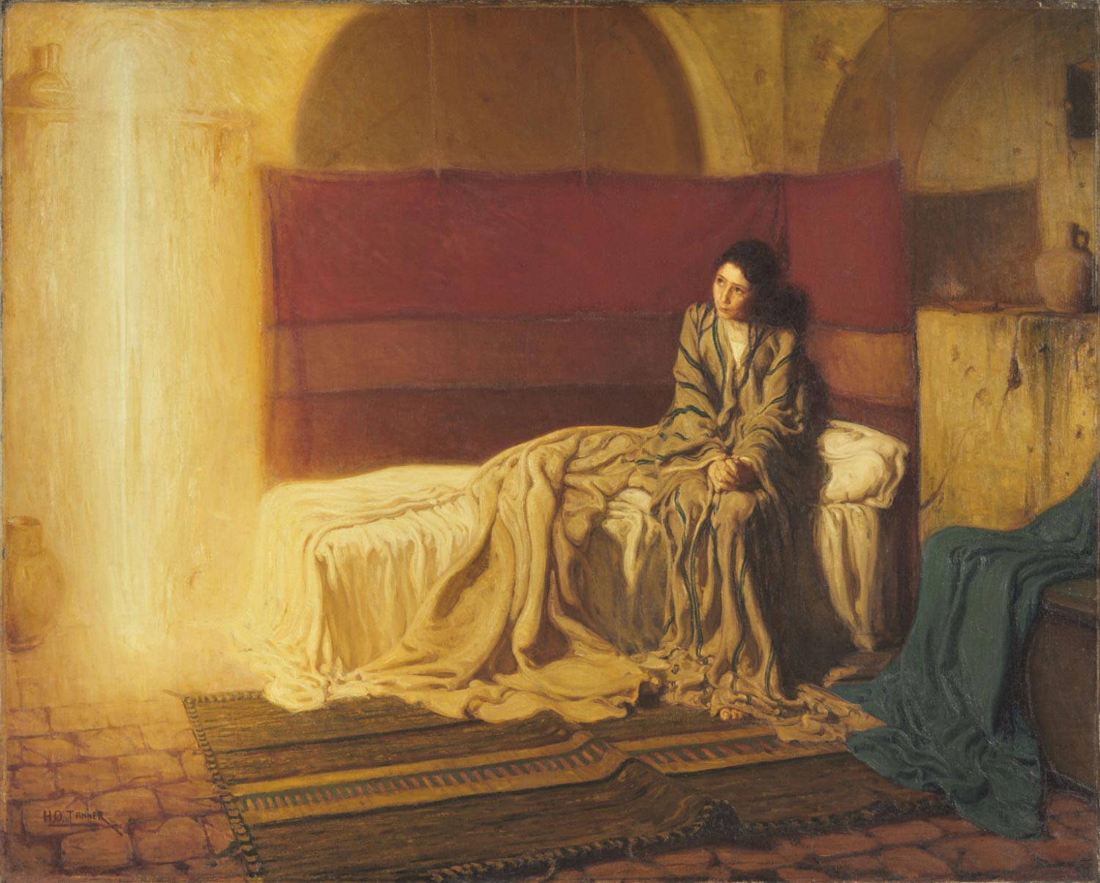
Contemplation on the Incarnation Part Two: Mary’s Human Response By Daniel Ruff, SJ

A recurring pattern in the Spiritual Exercises has St. Ignatius starting the retreatant off praying at the “cosmic” level, and then leading him or her gradually to the more intimate and personal plane. This pattern is certainly operational in the Ignatian contemplation on the Incarnation.
Thus, Ignatius invites the retreatant to enter imaginatively into the God’s-eye view of the unredeemed human condition in the first “panel” of the diptych. Responding with a “leap of divine joy” born of love, the triune God decides to “work the redemption of the whole human race.”
Note, then, the dramatic shift as one moves to the second “panel” of the diptych. The subject matter of the second half of the meditation is found in Luke 1:26–38, the account of the Annunciation. As Fr. Fleming puts it, “I try to stay with the eyes of God, and look upon the young girl Mary as she is greeted by God’s messenger, Gabriel.”

Give this a try. Be present to the scene, “hearing the nuances of the questions, seeing the expression in the face and eyes [of Mary], watching the gestures and movements which tell us so much about a person.” In other words, get to know Mary intimately―this young, simple girl from a small town whose yes to God makes possible “the redemption of the whole human race.”
Keep the cosmic sweep, the eternal significance of what the Triune God is doing, as a backdrop. But then, zoom in for the close-up on the surprising ordinariness of the scene: an obscure provincial town, a humble single-room dwelling. A young girl, not long past puberty, of ordinary lineage and meager means. As your imagination presents her, is she doing housework? Perhaps embroidering a towel? Maybe praying or daydreaming?
Into this mundane domestic setting comes the angel, Gabriel. And what is that like? Does the angel have wings, as in so many paintings? In one famous and beautiful rendering by Henry Ossawa Tanner, the angel is depicted as a glowing column of light at the foot of the bed where an adolescent Mary is seated. How does Mary react to this divine intrusion? How would you react? Luke reports that she is “troubled” at the angel’s words and ponders, “what sort of greeting this might be.” (“Oh, Lord! What does one say to an angel? Why me? And what on earth could God possibly want?”)

Encouraging her not to be afraid, Gabriel announces that she has, “found favor with God,” and will conceive and bear a son to be named Jesus. “He will be great and will be called Son of the Most High, and the Lord God will give him the throne of David his father, and he will rule over the house of Jacob forever, and of his kingdom there will be no end.” If you were 14 or 15, what would you make of all that? Would you perhaps wonder if you were ill and hallucinating? Would you wonder, What will my parents say? And Joseph?!?

As it happens, Mary asks a practical question. How can all this come to pass? Maybe she is partly reasoning with herself. She is, after all, a virgin. The response comes, “The holy Spirit will come upon you, and the power of the Most High will overshadow you. Therefore the child to be born will be called holy, the Son of God.” Wow! Is that helpful? Is it welcome news? Or is it just scarier and more confusing? Yet somehow, Mary finds the inner courage and strength and faith to respond, “Behold, I am the handmaid of the Lord. May it be done to me according to your word.”

As you immerse yourself in the mystery of the Incarnation in your mind’s eye, “[you] may want just to stay with Mary or with the eternal Word, who has now become human―for [you]…. [You] may want to speak out [your] joy, [your] thanks, [your] wonder, or [your] praise to the three Divine Persons.” The human race waited for centuries of struggle and hope until God made this astonishing and utterly unpredictable move. Allow yourself to wait on God’s grace, hoping and trusting that you will be granted deeper understanding of what all the Christmas fuss is really about.

All textual quotes from David L. Fleming, SJ, Draw Me Into Your Friendship: A Literal Translation and a Contemporary Reading of the Spiritual Exercises, St. Louis: Institute of Jesuit Sources, 1996.

