This month (January)
we celebrate the life and memory of
Father Inácio de Azevedo, S.J.,
who was martyred in 1570
along with 39 Jesuit companions.

- Charged with responsibility for the missions in Brazil,

Blessed Inácio de Azevedo
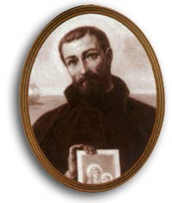
Jesuit missionary and martyr

Father Inácio was returning there with the 39 companions
he had recruited to work the mssions, when their vessel
was attacked by a pirate ship.
- Historical accounts report that the pirates were
French Huguenots, bitter enemies of Catholicism,
whose vicious attack was spurred by religious fervor.
- “Put to the sword” scarcely describes the savage
martyrdom of the Jesuits when the pirates prevailed.
- Rather than raise weapons in defense of a lost cause,
the Jesuits instead cared for the wounded and dying
sailors, administering the Last Rites.
- They were beatified by Pope Pius IX in 1854.

As we ponder the sacrifice and devotion of the
Jesuit martyrs, let us recall the words of our
Holy Father, Pope Francis, expressing these reflections
about another group of Catholic martyrs:
“The Sainted Fathers say: ‘Let’s imitate the martyrs!’ We must always die a little in order to come out of ourselves, of our selfishness, of our well-being, of our laziness, of our sadnesses, and open up to God, to others, especially those who need it most.
We implore the intercession of the martyrs, that we may be concrete Christians, Christians in deeds and not just in words, that we may not be mediocre Christians, Christians painted in a superficial coating of Christianity without substance – they weren’t painted, they were Christians until the end. We ask them for help in keeping our faith firm, that even throughout our difficulties we may nourish hope and foster brotherhood and solidarity.”

