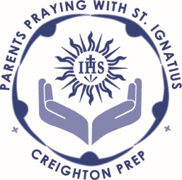
May 2017 Intentions

We pray for the intentions of Pope Francis this month:

Universal: Christians in Africa: That Christians in Africa, in imitation of the Merciful Jesus, may give prophetic witness to reconciliation, justice, and peace. [read the reflection]
We pray for Church leaders at all levels.
We pray especially for the Jesuits serving at Creighton Prep
.
We pray for the Prep administrators, faculty, staff and Jesuits
FINANCE AND OPERATIONS - Sue Mehal
HIGH SCHOOL OFFICE - Kath Harmon, Jackie Lesiak, Sonia Mapes, Catherine Gordon, Dan Schinzel, Chris Searl, Jim Bopp, Joe Pick, Josh Luedtke
INFORMATIONAL COMMUNICATIONS - Matt Rasgochek and Adam Winters
Buildings and Grounds - Luke Fischer, Kevin Flint, Phil Franco, Dan Gable, Dave Leahy, Joe Robbins, Gabe Robinson, Dan Vacek

We pray for God’s guidance over the students at Prep and their many activities.
Advanced Placement Exams | Alumni Breakfast | Ascension Thursday | Awards Ceremony
Faculty/Staff Ignatian Breakfast | Big Brother/Little Brother Picnic | Board of Trustees meeting | Chamber Choir Auditions
Emergency Day | Graduation | Graduation Mass
Parents Praying with St Ignatius | Saturday Jug | Semester Exams | Senior Exams
Spring Choir concert | Summer Band | Junior Parent meeting with College Counseling

We pray for all Prep Alumni.
That they will continue to live out their faith in the community.
We pray for the boys celebrating birthdays:
Add your own birthdays now
We pray for the ill and deceased,
For all deceased Creighton Prep alumni, all the souls in purgatory, and especially for our family and
friends whom we recall now. Add your own deceased loved ones now
May they rest in peace and the perpetual light shine upon them.
We pray for our intentions:
Add your own intentions now…

