Catholic Traditions: Advent
“The Great O's of Advent"
On the evening of December 17 the final phase of preparation for Christmas begins
with the first of the great "O Antiphons" of Advent.
These prayers are seven jewels of liturgical song, one for each day until Christmas Eve.
They seem to sum up all our Advent longing for the Savior.
December 17: O Wisdom, that proceedest from the mouth of the Most High, Reaching from end to end mightily, and sweetly disposing all things: come and teach us the way of prudence.
December 18: O Lord and Ruler of the house of Israel, Who didst appear unto Moses in the burning bush, and gavest him the law on Sinai: come and redeem us by Thy outstretched arm.
December 19: O Root of Jesse, Who standest as the Ensign of the people, before Whom kings shall not open their lips; to Whom the Gentiles shall pray: come and deliver us, tarry now no more.
December 20: O Key of David, and Sceptre of the house of Israel; Who openest, and no man shutteth, Who shuttest, and no man openeth: come and lead the captive from the prison house, and him that sitteth in darkness and the shadow of death.
December 21: O Dawn of the East, Splendor of the eternal Light, and Sun of justice: Come and enlighten them that sit in darkness, and the shadow of death.
December 22: O King of the gentiles, yea, and the desire thereof, the Cornerstone that makest both one: come and save man, whom Thou hast made out of the slime of the earth.
December 23: O Emmanuel, our King and Lawgiver, the expectation of all nations and their Salvation: come and save us, O Lord our God.
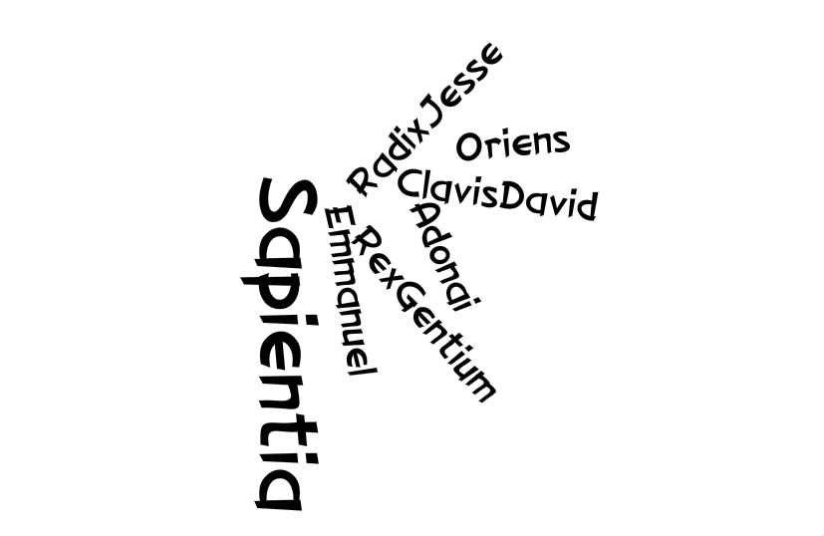
The exact origin of the “O Antiphons” is not known. Boethius (c. 480-524) made a slight reference to them, thereby suggesting their presence at that time. At the Benedictine abbey of Fleury (now Saint-Benoit-sur-Loire), these antiphons were recited by the abbot and other abbey leaders in descending rank, and then a gift was given to each member of the community. By the eighth century, they are in use in the liturgical celebrations in Rome.
The usage of the “O Antiphons” was so prevalent in monasteries that the phrases, “Keep your O” and “The Great O Antiphons” were common parlance. One may thereby conclude that in some fashion the “O Antiphons” have been part of our liturgical tradition since the very early Church.

